Dis-Fossils-US-IL-Mazon Creek-Bird

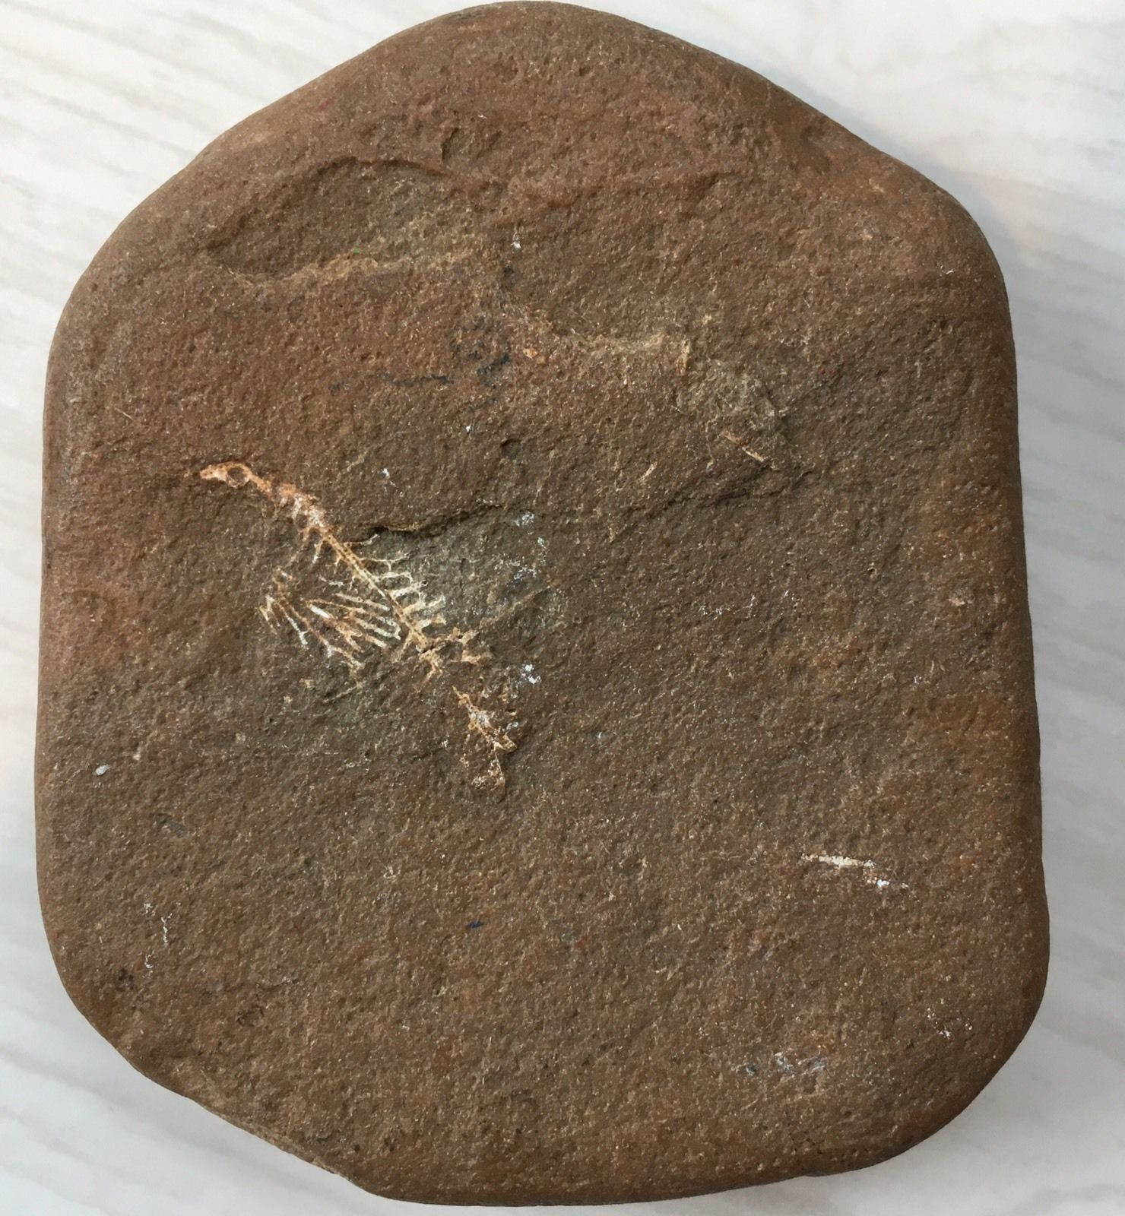

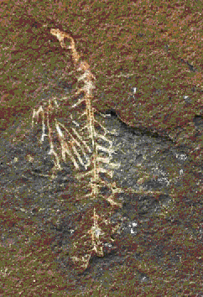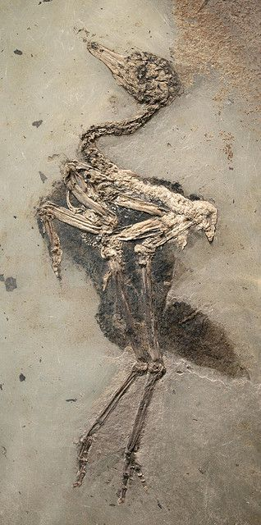

Left: Mazon Creek 323.2 Ma (million years ago) to 298.9 Ma

# Right: Eocene bird 48 million years old

**Formal Label:** Fossils-US-IL-Mazon Creek-

Accession Number:

**LC Classification:**  QE747.I3

Date or Time Horizon: 323.2 Ma (million years ago) to 298.9 Ma

Geographical Area: Braidwood site, pit 11, Mazon Creek, IL. 41°19′16″N 88°20′46″W / 41.321°N 88.346°W

**Map:** after Shabika and Hay 1997. The stippled area indicates the Pennsylvanian sea. Braidwood site, pit 11. is to the lower, center-right.

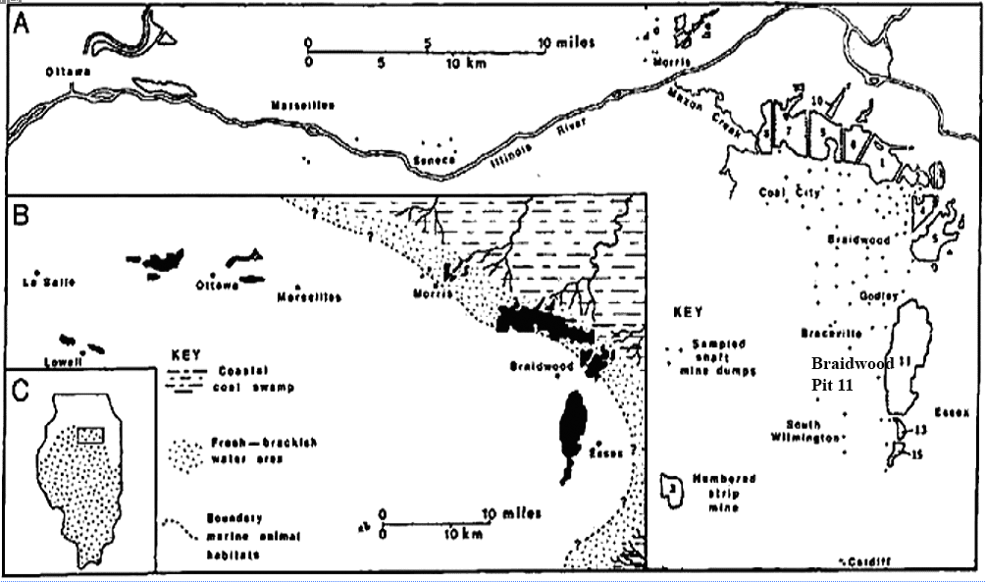

Geological Affiliation: mid-Pennsylvanian epoch of the Upper Carboniferous in the Francis Creek Shale

Medium: Ironstone fossil

Dimensions:

Weight:

Condition: Museum quality.

Provenance: This specimen was collected at the Braidwood site, pit 11, IL.

**Discussion:** The Mazon Creek fossil beds, Grundy County, Illinois are preserved in ironstone (sandstone with iron oxides) as concretions that were formed approximately 323.2 Ma to 298.9 Ma during the mid-Pennsylvanian epoch of the Upper Carboniferous in the Francis Creek Shale. The ironstone concretions preserved faunal soft tissues in detail, which are not normally fossilized (Allison 1987) and faunal hard tissues and flora in great detail because their remains were rapidly buried before much decomposition could set in (Bottjer 2002). The organisms acted as chemical nuclei that precipitated siderite nodules that encased the micro structure of the fossils in a process known as authigenic mineralization (Schellenberg 2002).

**References:**

Allison, P. A. 1987. "A new cephalopod with soft parts from the Upper Carboniferous Francis Creek Shale of Illinois, USA," *LethaiHYPERLINK "https://en.wikipedia.org/wiki/Lethaia"a,* **20** (78): 117–121.

Dawson, Michael N. 2003. "Macro-morphological variation among cryptic species of the moon jellyfish, *Aurelia* (Cnidaria: Scyphozoa)," *Marine Biology*. **143** (2): 369–379.

Nitecki, Matthew H., ed. 1979. *Mazon Creek Fossils*. *Papers presented at the symposium sponsored by the Paleontological Society and the Field Museum of Natural History.* New York: Academic Press.

Shabica,  Charles W. and Andy Hay. 1997. *Richardson's guide to the fossil fauna of Mazon Creek*. Chicago, IL: Northeastern Illinois University**.**

Schellenberg, Stephen A. 2002. "Mazon Creek: preservation in late Paleozoic deltaic and marginal marine environments" In Bottjer, David J. 2002. *Exceptional Fossil Preservation: A Unique View on the Evolution of Marine Life.* New York: Columbia University Press, pp. 185–203.